**New Subcon import file**

Description: new file format will include Split request and SO.

Development spec:

1. Create new import button function [Subcon v2]
2. Import function – will import SO for Subcon SO, and validate the split request field, if required split, system will import records to Split Request table.

Source file:

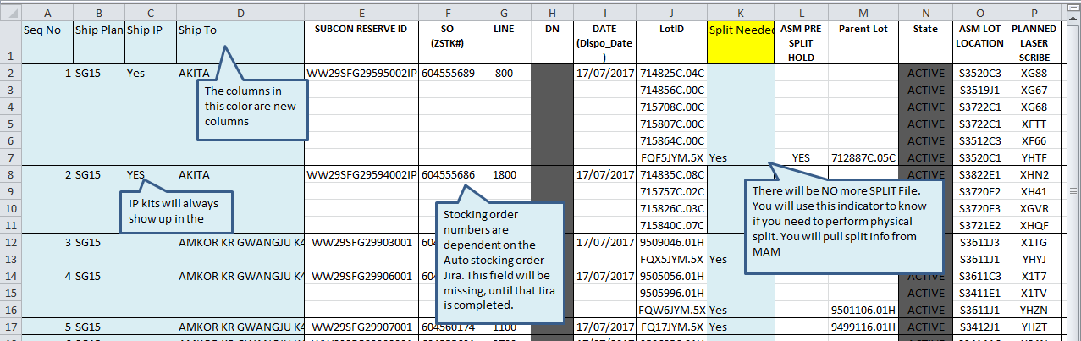

on the new subcon file column K will advise if this lots is needed for splitting, therefore column M will advise the parent lots no to scan for split request scanning.

Date:2017-09-07

WMS Update

1. Import SO

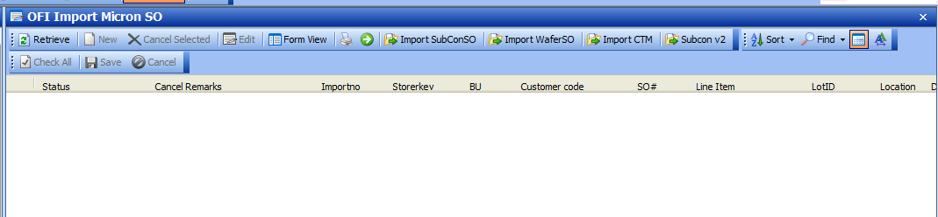

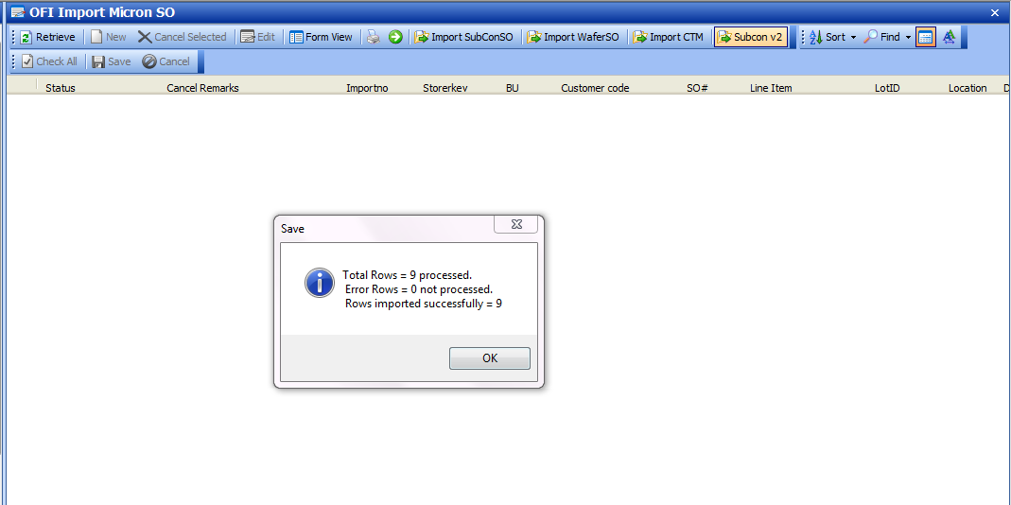

1. Subcon Order will be created

2. Split Request will be created if Split needed = ‘Yes”

